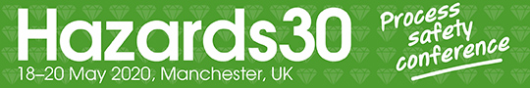

Dear [NAME]

I’m writing to request your approval to attend Hazards 30 at Manchester Central, UK on 18–20 May 2020.

This annual event brings together process safety practitioners for two days of unparalleled learning and networking opportunities. With every major aspect of process safety covered, it will help me to stay up to date with good practice, new techniques and approaches, and lessons learnt from past incidents and near- misses. The quality-assured presentations delivered by established practitioners and industry experts will help to develop my professional expertise, enhance the value of our team and influence our safety decisions.

While attending, I’ll have the chance to strengthen our industry connections and network with like-minded peers and industry experts. I’ll get to make new contacts, discuss our challenges and find new solutions in an extensive exhibition alongside the conference. It will also be an opportunity to benchmark [COMPANY NAME] against other companies in our sector.

I plan to grow and develop my knowledge in [X], [Y] and [Z] by cherry-picking the most appropriate workshops and presentations that are directly related to my role and our team’s objectives.
I’ll come away with copies of the speaker papers and presentations that I’ll be able to share with the team too.

The delegate fee is £875 for IChemE members / £975 for non-members until Friday 6 March 2020. After that it increases to £975 for IChemE members / £1,150 for non-members. Please bear in mind this deadline in your approval.

I’d be delighted to submit a formal report following the conference that summarises the major concepts, action items and learnings I find. I truly feel attending the event is a worthwhile investment for the business.

Let me know if you have any further questions. Happy to discuss.

Kind regards,

[YOUR NAME]

