Process Safety Considerations During COVID-19: Panellists
Trish Kerin
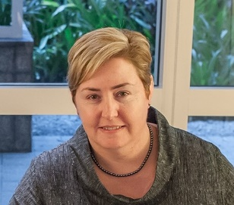
Trish spent several years working in project management, operational and safety roles for the oil, gas and chemical industries.
She has represented industry on many government committees related to process safety and sits on the board of the Australian National Offshore Petroleum Safety and Environmental Management Authority (NOPSEMA) and the Mary Kay O'Connor Process Safety Centre (MKOPSC) steering committee.
Trish is a Chartered Engineer, registered Professional Process Safety Engineer, Fellow of IChemE and Fellow of Engineers Australia. She holds a diploma in OHS and is a graduate of the Australian Institute of Company Directors (GAICD).
In 2015, Trish received the John A. Brodie Medal from Engineers Australia for her paper on Process Safety Competency at the Asia Pacific Congress of Chemical Engineering and in 2018 received the Trevor Kletz Merit Award from the MKOPSC for her work in process safety internationally.
Mark Hailwood
Mark has 29 years’ experience working in Major Accident Hazards regulation.
He is a member of the OECD Working Group on Chemical Accidents and has many years’ experience working with Major Hazard Inspectors at national (DE) and international level, particularly with the EU JRC Major Accident Hazards Bureau (MAHB).
Mark is also a member of the IChemE Loss Prevention Panel
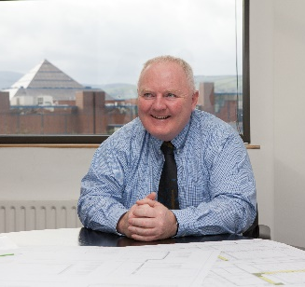
Pat Swords
Pat Swords is a Fellow of the Institution of Chemical Engineers and a Professional Process Safety Engineer. He has more than thirty years of experience with PM Group in the design and regulatory compliance of industrial projects in Europe, USA, Asia and the Middle East covering such sectors as chemicals, pharmaceuticals, food and energy. Between 2000 and 2016, he was extensively involved as a consultant on EU technical aid projects in Central and Eastern Europe implementing the industrial pollution control and control of major accidents legislation.
Christopher G Ross
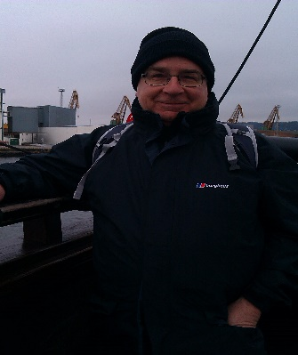
Chris has 40 years’ experience in Process Support, Technical Safety, Operations Engineering, Projects, Turnarounds and Modifications Authority in the Petrochemical industry
Christopher is currently Deputy Project Manager IChemE’s COVID19 Response team, a member led group of chemical engineers and life scientists working in collaboration with the International Society for Pharmaceutical Engineering (ISPE) to address any challenges relating to COVID-19.

Session Convenor
Liz Hallifax
Liz has twenty years’ experience in operations and design across energy, oil and gas and FMCG and is a MIT Sloan graduate. She is currently Technical Authority responsible for Unilever’s process safety governance across all operations worldwide.

